Evergreen Executive Source

Chief Executive Officer
Greenville Headquarters
Position to be filled immediately
Apply now for consideration!

The Girl Scouts of South Carolina Mountains to Midlands Council announces a search partnership with Evergreen Executive Source, LLC to identify candidates and advise on the selection of a new CEO. Evergreen is a retained search firm with depth of experience in nonprofit executive sourcing and selection, and has conducted searches nationwide for over a decade serving the interests of Girl Scout councils across the entire country. All information provided to Evergreen will be treated with the utmost confidentiality.

THE ORGANIZATION

The Girl Scouts of South Carolina Mountains to Midlands Council is the preeminent organization serving the interests of girls across 22 counties in Central and Western South Carolina, seeking to inspire and nurture the greatness in every girl, empowering her to pursue her dreams, and make the world a better place. The Council has current membership of 8,000 girls, 3,000 valued adult volunteers, and a staff of 45 full- and part-time employees. It has an annual operating budget of $5.2 million, and operates service centers in Greenville and Spartanburg, and the soon to open Cathy Novinger Girl Scout Leadership Center in Columbia. At Girl Scouts, girls unleash their inner G.I.R.L. (Go-getter, Innovator, Risk-taker, Leader)™ through a collection of engaging, challenging, and fun programs to encourage and foster leadership development by participation in a variety of activities, including outdoor adventure and education, STEM exploration, travel, arts, community service projects and career exploration through a variety of badge activities. All Girl Scouting programs and activities are designed to challenge and prepare girls for a future of leadership and achievement.

THE OPPORTUNITY

The CEO will act in partnership with the Board of Directors to plan and ensure excellence in program delivery and outcomes, and place the Council among the nation’s leaders in membership growth, services and innovation. The CEO will direct the Council’s strategic plan through the formulation and implementation of short and long range goals and objectives that prioritize investments in girls. In addition, the CEO will ensure that pluralism is a core value within the Council’s activities and functions, promoting opportunities for participation in every aspect of Girl Scouting.

Responsible for stewardship of the Council’s human, material and fiscal assets, the CEO provides oversight for policies and practices that enhance and leverage the participation of staff and volunteers to effectively engage girls, families, and volunteers in the Council’s large service area. The CEO’s important outward-facing responsibilities are to expand the Council’s visibility and create opportunities for significant strategic partnerships and financial support. The CEO will build relationships with corporate, nonprofit, government, and funding communities by representing the Council at strategic functions and influential speaking opportunities.

CRITICAL GOALS

Successful measures of accomplishment will be determined in the following areas:

Membership growth:
- Ensure growth of girl and adult membership through recruitment and retention plans and programs meeting the Council’s strategic priorities.
- Provide leadership for the implementation of the Council’s strategic plan with particular focus on membership growth, creating a rewarding volunteer experience and expanding quality program opportunities.
- Ensure execution of Council mission delivery goals, especially girl membership growth, quality programming, and membership satisfaction.

Community relations/fundraising:
- Increase organizational visibility throughout the Council’s jurisdiction to promote fundraising and friend raising among diverse revenue streams and sources.
- Promote a culture of philanthropy and giving to support Council programs, ensuring diverse, reliable, sustainable funding, and financial stability.
- Elevate the Girl Scout mission and brand in the region, to increase the Council’s visibility and generate increased opportunities for community engagement with partners, funders, and community organizations.
- Develop and cultivate relationships throughout all stakeholder groups to increase community support, funding, and brand awareness, and ensure a welcoming environment to all.
- Increase public support revenue, diversifying Council revenue streams to lessen the dependence on the cookie program.

Strategic planning:
- Apply a strategic approach to all aspects of operations and governance including: succession planning, processes, frameworks, alignment with GSUSA, and change management initiatives.
- Employ effective vision and strategic planning skills to bring ideas from concept to implementation, while ensuring strategic learning within the organization.

CEO QUALIFICATIONS

The ideal candidate will possess outstanding dedication to the nonprofit sector, with emphasis on youth-serving programs. In addition, this individual’s strengths will include broad-based business skills with a minimum of five years’ comparable executive-level experience, and ten or more years in leadership roles of progressive responsibility. The new CEO will have demonstrated ability in fundraising, direct sales skills and experience, and fiscal management of significant budgets; all demonstrating the ability to manage the Council’s budget of $5.2 million. The ability to model leadership skills in the recruitment, management, development and retention of paid staff and volunteers is essential.

The CEO will exhibit servant leadership, with an emphasis on personal integrity and commitment to the Girl Scout Promise and Law. The CEO must be able to lead the Council through a combination of clear vision and strategic operational planning abilities. The CEO will possess a style of leadership that is transparent, collaborative, inclusive, embraces partnerships, and empowers stakeholders to achieve their highest potential, all while satisfying accountability measures mutually agreed upon with the Board. The CEO will have the personal and executive presence to be recognized as a community and business leader in the region. It is essential that the CEO have a strong commitment to serving girls from all family, community, and economic backgrounds.

Additional desired qualifications include nonprofit board relations, marketing, sales and financial acumen, and volunteer relations leadership. The CEO is expected to possess a minimum of an earned bachelor's degree, with advanced degree and relevant training desired.

Skilled executives from the world of Girl Scouting, corporate, nonprofit, or other professional backgrounds who are dedicated to providing world-class development opportunities for the young women and girls in Central and Western South Carolina are encouraged to apply. If this is your background, and you share a passion for advancing the lives of girls in this service area, we want to speak with you.

COMPENSATION/BENEFITS

The Council offers a competitive compensation and benefits plan with annual pay commensurate with experience. It provides a comprehensive benefits package which includes medical, dental, vision, long- and short-term disability, life insurance, AD&D, a flexible spending account, as well as attractive personal time off program. Other features include a 401K plan with Council match, and an employee assistance program. Benefits are subject to change at the discretion of the Council. Relocation support will be considered.

COUNCIL JURISDICTION

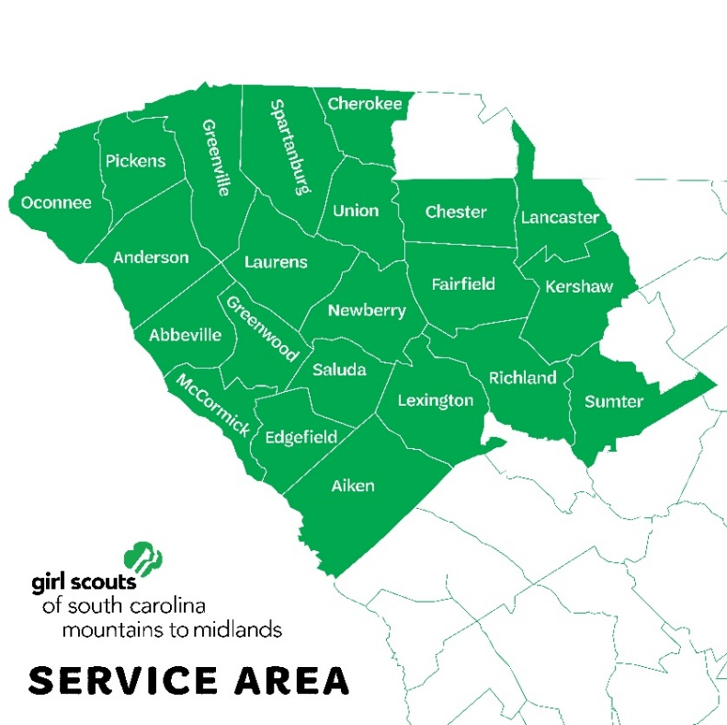

COUNCIL WEBSITE: https://www.gssc-mm.org/

HOW TO APPLY

Girl Scouts of South Carolina Mountains to Midlands is an equal opportunity employer.

We encourage expressions of interest as soon as possible for this accelerated search. For consideration, please e-mail your cover letter and resume to:

Bob Perodeau, Principal
Evergreen Executive Source, LLC
E-mail: evergreen.source@att.net
Voice (800) 286 4009 www.egreensource.com

Providing executive recruiting services to Girl Scouts of the USA since 2001

