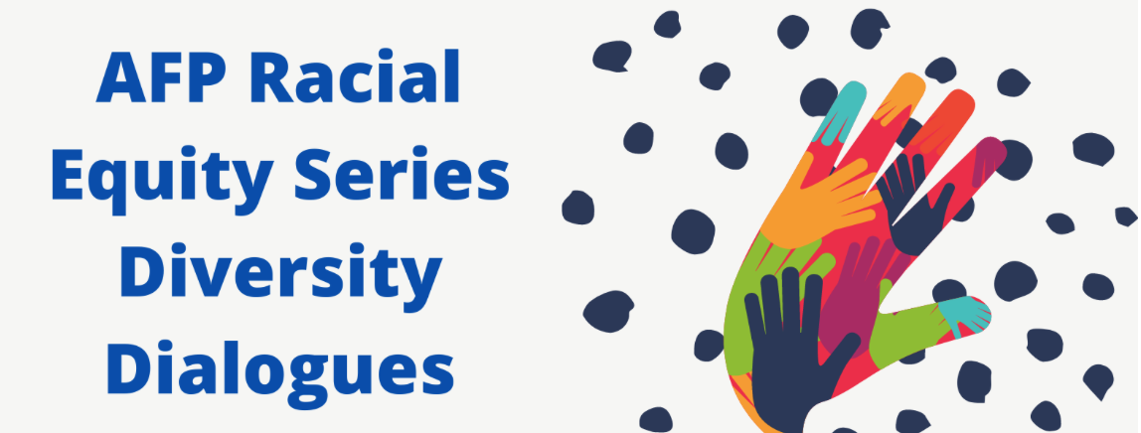
Thursday, September 3rd
12 noon – 1:00 p.m.

Deliberate Dialogues with
Darryl White, Sr., Assistant Dean – Diversity, Inclusion and Community Engagement, Queens University of Charlotte
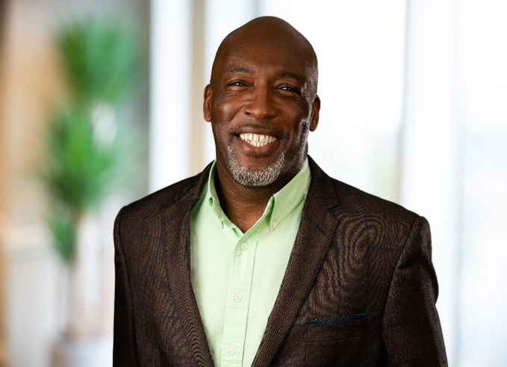
Darryl White Sr. started in his role as Assistant Dean of Diversity, Inclusion and Community Engagement at Queens University of Charlotte in November 2016. Prior to coming to Queens, he served as Vice President of Family Services at Habitat for Humanity of Charlotte for 22 years. Darryl retired from the U.S. Army Reserves in March 2020 after 34 years of distinguished service where he attained the rank of Command Sergeant Major, the highest enlisted rank in the Army.

Darryl is a 1992 graduate of Queens University of Charlotte where he was a student-athlete and majored in Sociology and is currently pursuing a Master of Science in Organization Development (MSOD) at Queens (2021). Darryl is a 2007 graduate of the United States Army Sergeants Major Academy, an accredited academic Institution of Excellence for the Army’s noncommissioned officers. He is also a 2008 graduate of Community Building Initiative’s LDI Program, a signature 12-month program which supports non-profit board members and senior staff of non-profit, public and for-profit organizations in the leadership role they and their organizations play in building a more inclusive and equitable Charlotte-Mecklenburg. He previously served on the Queens Alumni Board and on the Queens Center for Active Citizenship Advisory Board. Darryl serves on the Executive Committee and board at Charlotte Mecklenburg Housing Partnership where he previously served as chairman. He is also active with several other local nonprofit agencies.

Darryl is a skilled facilitator with expertise in diversity, equity, and inclusion, communication, and leadership.

